Symbiosis Institute of Management Studies, Khadki, Pune
EVALUATION SHEET
(COVER PAGE)
INTERNAL EVALUATION/ ASSIGNMENT NAME & No:
Machine Learning SEM-IV Assignment-I
(Internal)
[Compulsory Submission for Internal Evaluation]

Subject Code : 20448429 Subject: Machine Learning
Prof. Name: Abhishek Mishra
Course/Program and Batch: MBA (executive) 2024-26 -- Weekday Online

PRN | Student Name | Signature | Remark
24020448074 | Sujitkumar Hujare | Sujitkumar Hujare

Date of submission: 28/ 01/2026
Submitted to: Email: ml@sims.edu

Evaluation:
Question | 1 | 2 | 3 | 4 | 5 | TOTAL  (Out of 30)
Marks Allotted

Evaluated by: ____________________
Signature of Faculty: ___________________
Date:________2026

CO₂ Emission Prediction Using Machine Learning

Use Case
The use case focuses on predicting CO₂ emissions from vehicles using machine learning based on key vehicle characteristics such as engine size, number of cylinders, and fuel consumption. The objective is to estimate the amount of CO₂ (g/km) emitted by a vehicle without conducting physical emission tests, enabling faster and cost-effective environmental assessment.

Why This Use Case Was Chosen
I choose this use case because Volkswagen account is handled by our organization. Transportation is one of the largest contributors to global carbon emissions, accounting for a significant share of greenhouse gases. Vehicle emissions directly affect air quality, public health, and climate change. This use case was chosen because:
- CO₂ emission prediction has high environmental and societal relevance
- It represents a real-world regression problem suitable for machine learning
- Automotive manufacturers and regulators require predictive tools for compliance and sustainability
- The relationship between vehicle features and emissions is quantifiable and data-driven
- It allows practical demonstration of model building, evaluation, and comparison

Source of the Use Case
Source of Data FuelConsumptionCo2.csv is from Canadian Government Open Data “Portal” and authorize from Natural Resources Canada – Office of Energy Efficiency Consist Of Data Vehicle models from 2000–2014 available publicly.

Approach Overview
A Linear Regression model was implemented to predict CO₂ emissions. Two separate models were trained using different input features:
- Model 1: Engine Size → CO₂ Emissions
- Model 2: Fuel Consumption → CO₂ Emissions
- Model 3: Multiple Linear Regression (Engine + Fuel) → CO₂ Emissions
All models were evaluated using R² score and RMSE to identify the most effective predictor. Fuel consumption showed higher predictive accuracy compared to engine size.

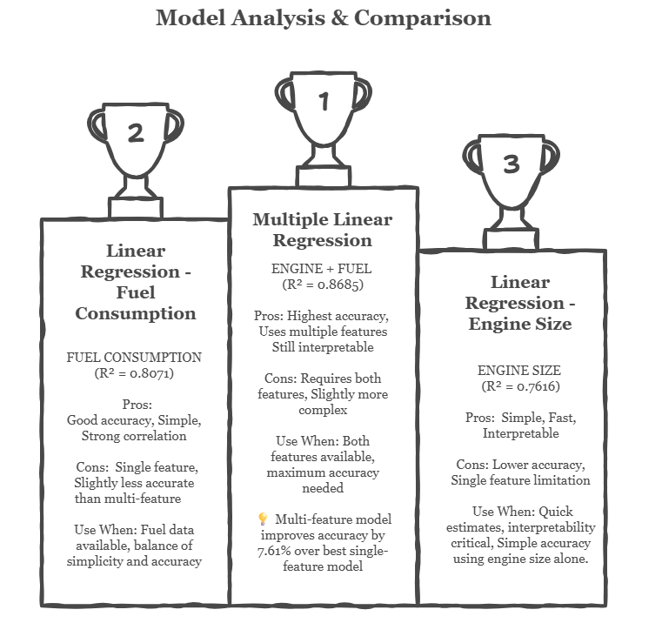

Model | MAE | MSE | RMSE | R² | Accuracy
Linear Reg (Engine) | 24.097257 | 985.938169 | 31.399652 | 0.761560 | 0.761560
Linear Reg (Fuel) | 20.441911 | 797.434631 | 28.238885 | 0.807147 | 0.807147
Multiple Linear Reg  (Engine + Fuel) | 17.033751 | 543.577810 | 23.314755 | 0.868541 | 0.868541

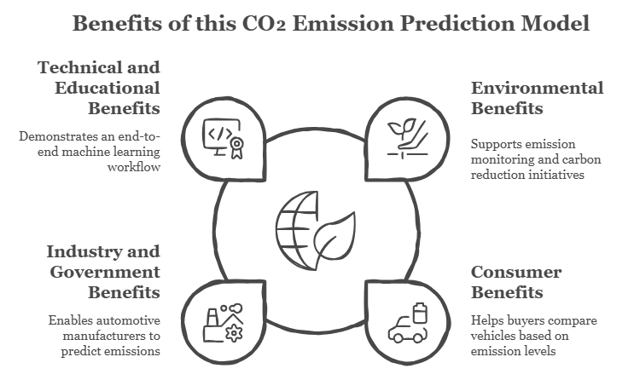

Conclusion
This project demonstrates how machine learning can be effectively applied to solve a real-world environmental problem. Multiple Linear Regression (Fuel + Engine) is best predictor (R² = 0.8685, and RMSE 23.31) and Next Fuel Consumption Model (R² =0.8072, RMSE=28.23) ssand Engine Size also reliable (R² = 0.7615, RMSE=28.23)
_______________________________________________________________________________

